https://cornershopapp.com/pt-br/products/36wrd-hote-vinho-tinto-chileno-gran-reserva-carmenere-750ml
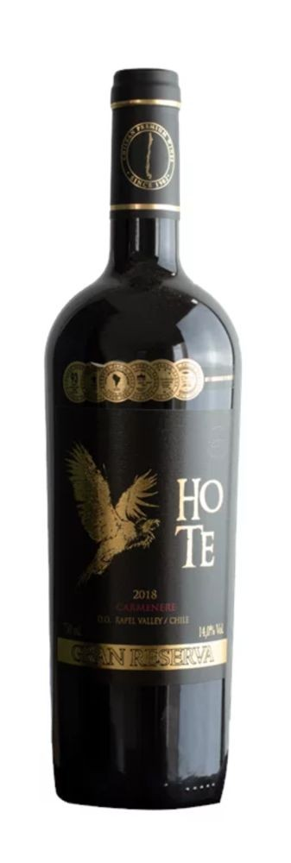

Hote Gran Reserva carménère
BODEGAS TAGUA TAGUA
VALLE DE RAPEL - CHILE

Safra 2018. Jantar em 18/04/2022.

